https://www.jdoodle.com/embed/v0/68fl
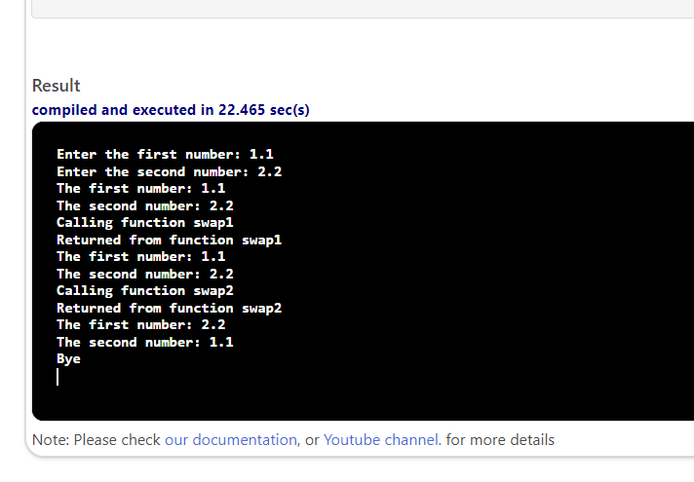

#include <iostream>
using namespace std;

void swap1(double n1, double n2);
void swap2(double &n1, double &n2);

int main()
{
double num1, num2;
cout << "Enter the first number: ";
cin >> num1;
cout << "Enter the second number: ";
cin >> num2;
cout << "The first number: " << num1 << endl;
cout << "The second number: " << num2 << endl;
cout << "Calling function swap1" << endl;
swap1(num1, num2);
cout << "Returned from function swap1" << endl;
cout << "The first number: " << num1 << endl;
cout << "The second number: " << num2 << endl;
cout << "Calling function swap2" << endl;
swap2(num1, num2);
cout << "Returned from function swap2" << endl;
cout << "The first number: " << num1 << endl;
cout << "The second number: " << num2 << endl;
cout << "Bye" << endl;
return 0;
}

void swap1(double n1, double n2)
{
double temp = n1;
n1 = n2;
n2 = temp;
}

void swap2(double &n1, double &n2)
{
double temp = n1;
n1 = n2;
n2 = temp;
}

